Little SPARK: Simple Play Adaptations to Reference for Kids

Jumbo Contoured Foam Grip
Description: | Image:
Full-length 4” foam pencil grip with a contoured, ergonomic design that facilitates an open web space. Jumbo Contoured Foam Pencil Grips are made of colorful dense foam that adds weight to writing utensils.  Purchasing Information | 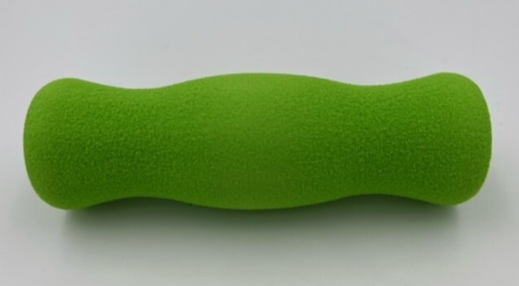

Who Might Benefit?
Those who hold their pencil too tightly, have reduced grip strength, demonstrate motor challenges, are sensory seekers or benefit from the use of tactile and visual cues to hold a pencil.
Why Use?
An opportunity to grip pencil comfortably, receive extra sensory input, and develop functional grasp for holding drawing tools.
Instructions for Use: | Adaptation Ideas:
Environmental Considerations  - Use in any environment with a hard surface to support the writing or drawing material.  Positioning & Alternate Positioning  - Use in any position; seated, standing, on the floor, with a slanted surface, on an easel/wall.  Basic Play/Use Extended Play/Use  - Copy, draw, and create Use with tools beyond drawing (e.g. paintbrush). | Build It Up  - Enlarge grip even more with Dycem, shelf liner, or other textured materials.  Stabilize It  - Use elastic hair tie, Wikki Stix, or small amount of tape if the writing tool is sliding in the grip.  Add Sensory Cues  - Add fidget to the eraser end of the pencil.  Communication Supports  - Provide a communication board with vocabulary appropriate for the activity.  DIY Alternative  - Create grip from pink sponge roller.

Words to Encourage Play/Use
Draw  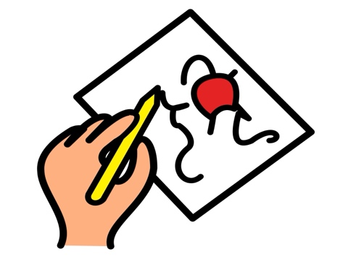 | Write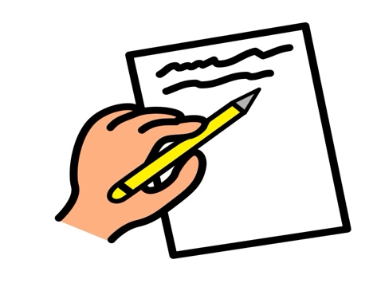 | Paper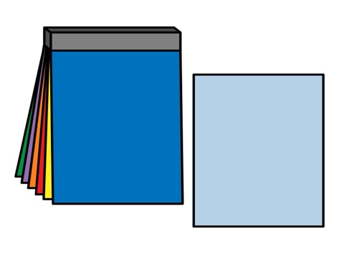
Trace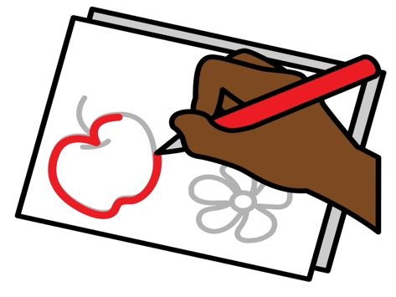 | Go | Stop
My Turn | Your Turn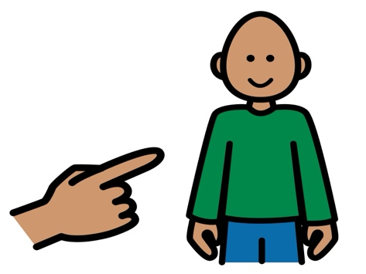 | Done  
*”Adaptations” adapted from: Haugen’s Modes for Adapting Toys based on materials from the "Let's Play" Project at the University of Buffalo
PCS is a trademark of Tobii Dynavox, LLC. All rights reserved. Used with permission.

